**BRIDGE ROAD SCHOOL** **NEWSLETTER**

127 Parramatta Road Camperdown 2025 Telephone:95198389 95198652 Facsimile:95196418

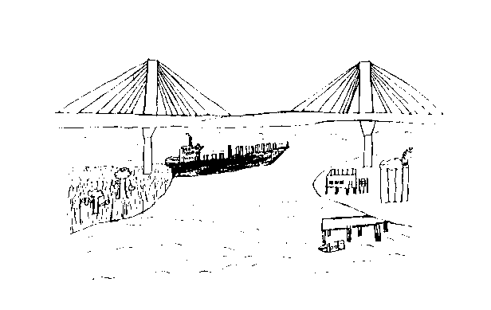

If your child does not attend the home school on a Thursday or on other integration days, please contact the office at Bridge Road as we are required to keep an accurate attendance register.

We would appreciate if the children do not bring toys or personal items to school.

If the children use iPads or other devices in the taxis, they know well the procedure of handing them in each morning and collecting them for the home trip.

Kind Regards

Jackie

04.02.15

Welcome to Term 1, 2015!

Dear Parents/Carers

Some children are in new classes this term – there may be more movement within the next couple of weeks.

Welcome to Emma, Jacky and Kristina who are on class…and welcome back to our substantive teachers – Melissa, Jerry and to Luanne, our Visual Arts teacher. Nigel will continue teaching music on Fridays.

Renny and Lorraine are the Assistant Principals

We also welcome back our support staff, Deb, Marie, Clare, Barry and Sergio who help support our children in the classrooms and playground. Sue and Allana in the office support all of us!

Our first round of Swim School commences at Victoria Park Pool on February 23 for 2 weeks. Not all children will be eligible for this program.

Renny is organising a trial “Bush School” program with our Stage 1 students at Centennial Park after swimming – more on this later too.

rs